**Drone project :**

Mani raj (ECE)

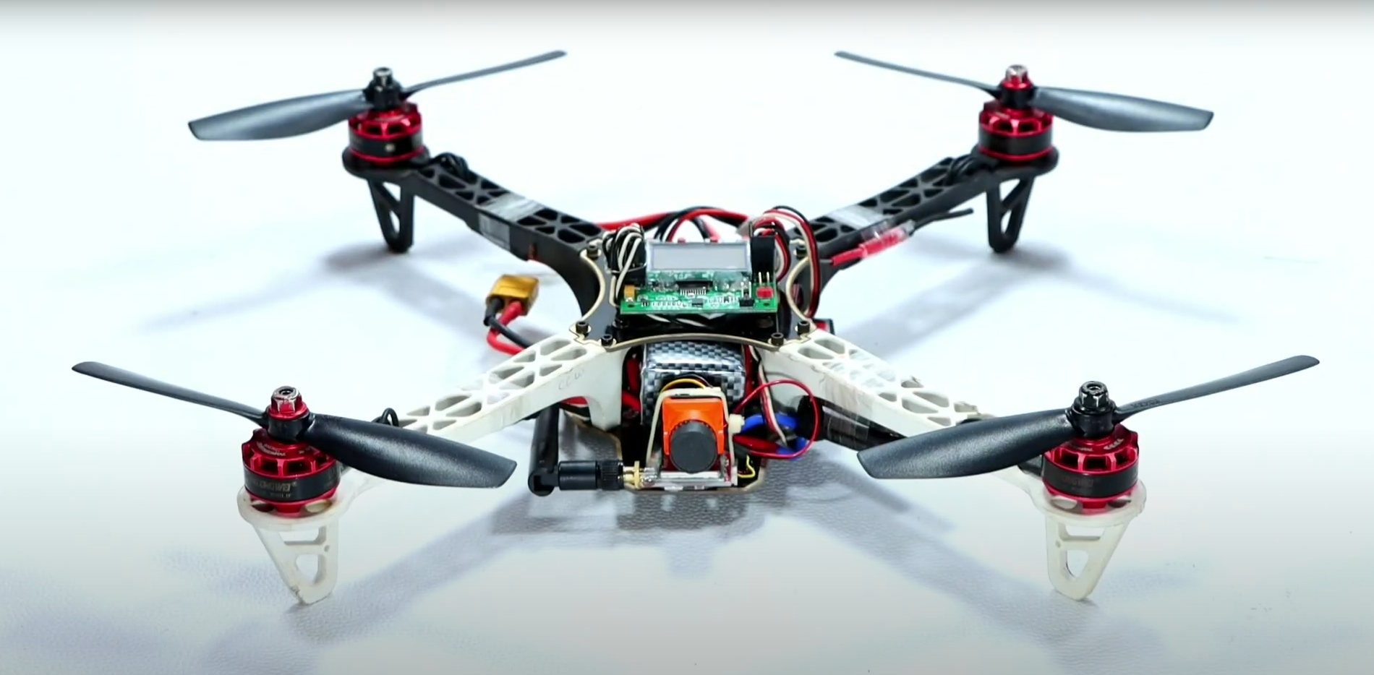

**Name of equipment :**

**1.qurtDrone Frame F450 /S500 :**

**S500:** [**Buy S500 Carbon Fiber Quadcopter Drone Frame Kit (robu.in)**](https://robu.in/product/s500-carbon-fiber-quadcopter-drone-frame-kit/)

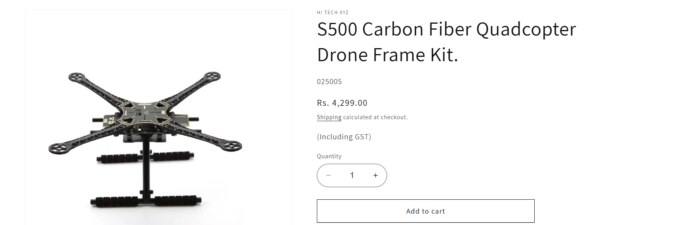

**2. Readytosky 2212 920KV CCW Self Locking Brushless Motor For Drone & RC Plane.**

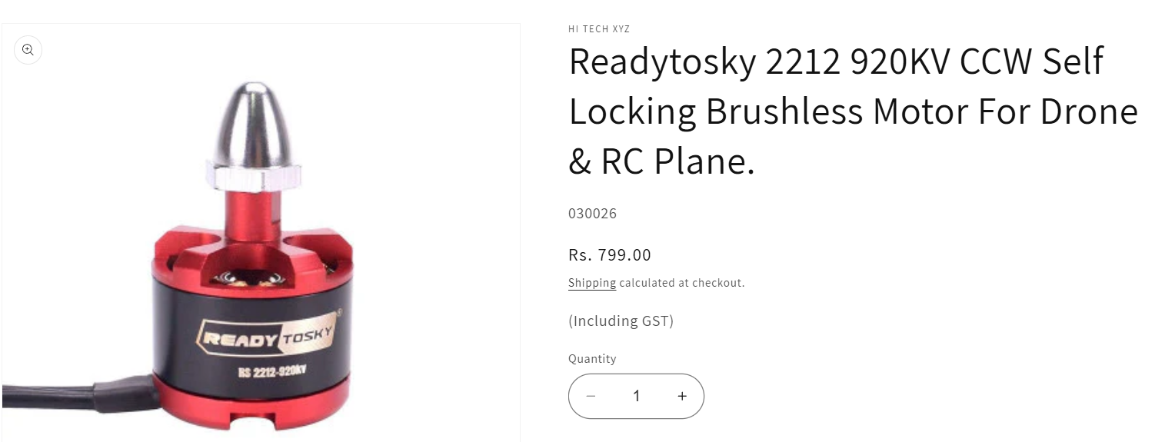

**DJI 2212 920KV Brushless DC Motor for Drone with Black Cap (CW Motor Rotation)**

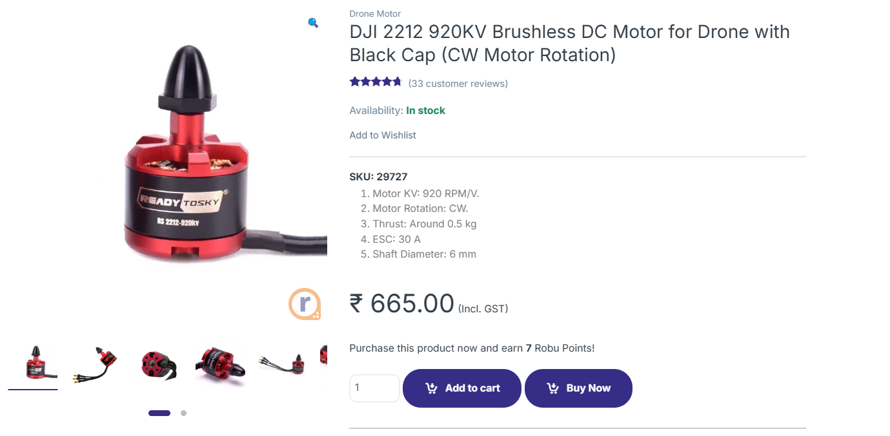

**3.Orange HD Propellers 1045(10X4.5) ABS DJI Black 2CW+2CCW-2pair-Premium Quality**

[**Buy Orange HD Propellers 1045(10X4.5) ABS DJI Black Online | Robu.in**](https://robu.in/product/orange-hd-propellers-104510x4-5-abs-dji-black-2cw2ccw-2pair-premium-quality/)

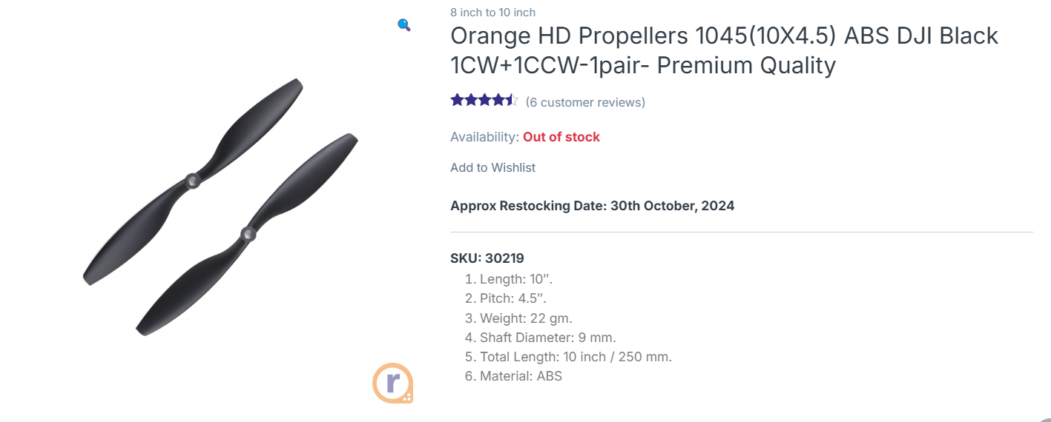

**4. Anti vibration shock**

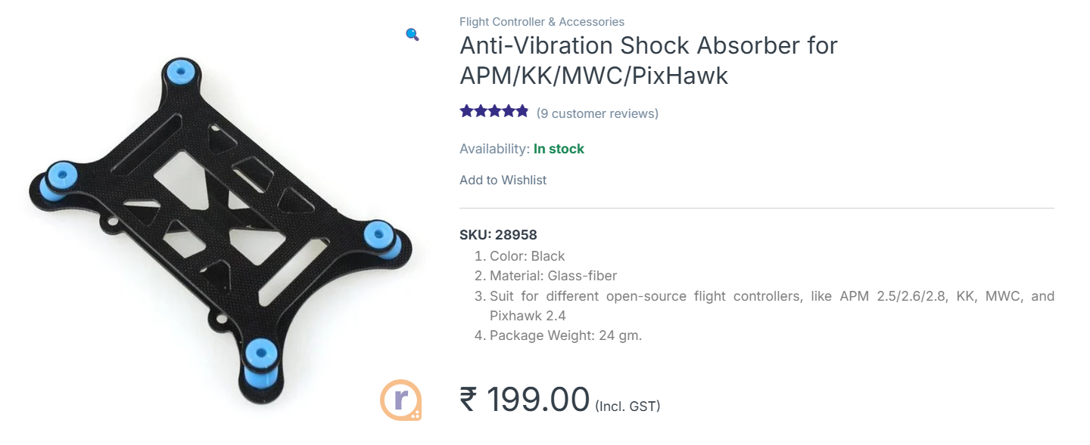

**5. 30A-S OPTO ESC For Drone**

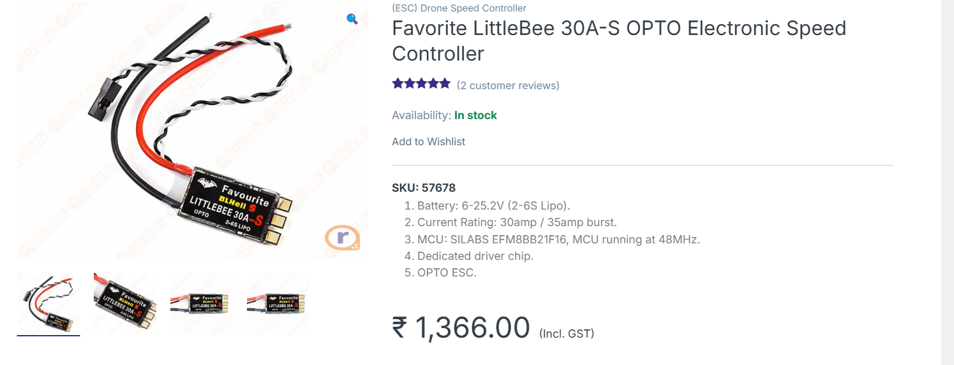

**6. Fight controller kit:**

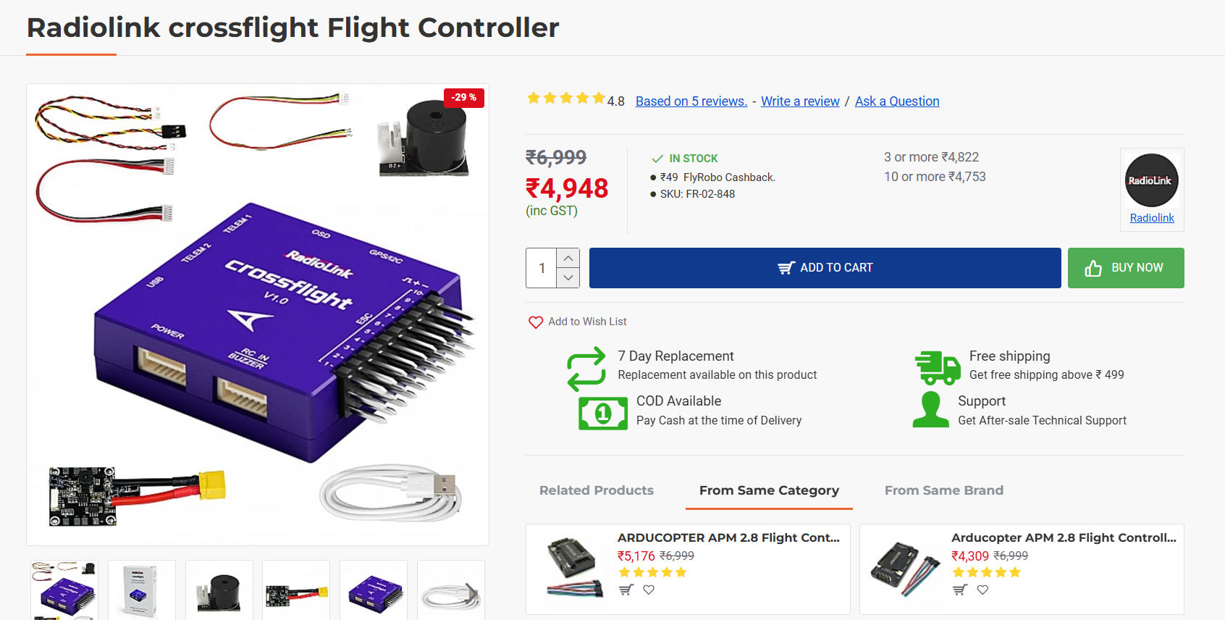

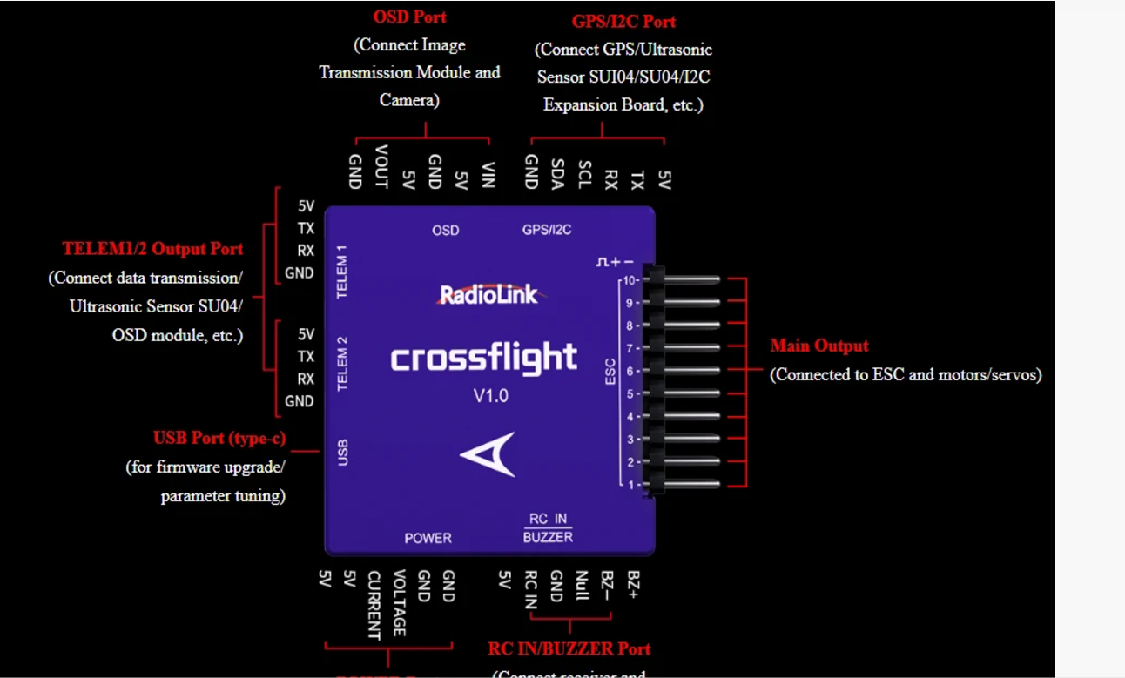

**7. Gps module with compass:**

[**Buy Ublox NEO 7M w/ Compass For APM & Pixhawk In India | Robu.in**](https://robu.in/product/ublox-neo-7m-gps-compass/?msclkid=8f8cedd8e24c1d9927858ac27bc4cc71)

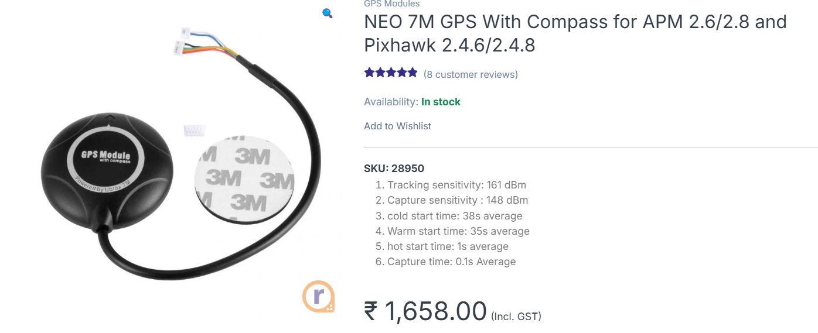

**8. GPS Folding Metal Stand For APM & PIXHAWK**

[**GPS Folding Antenna Metal Holder (flyrobo.in)**](https://www.flyrobo.in/gps_folding_antenna_metal_holder/)

**9 . 4500mAh 3S 35C 4s lithium polymer**

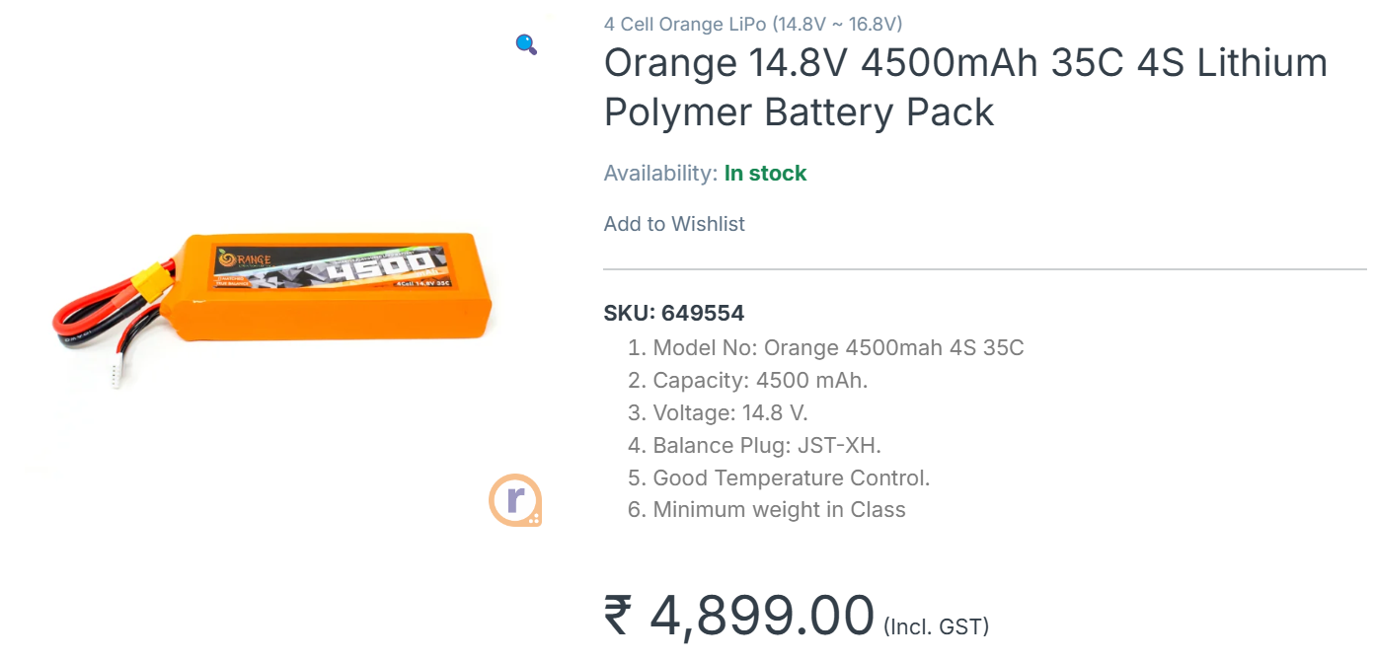

**10.** **FlySky FS-i6 2.4G 6CH PPM RC Transmitter With FS-iA6B Receiver**

**Rated 4.55 out of 5 based on 11customer ratings**

[**Buy Flysky FS-I6 2.4GHz 6CH PPM Transmitter w/ FS-iA6B Receiver India (robu.in)**](https://robu.in/product/flysky-fs-i6-2-4g-6ch-ppm-rc-transmitter-with-fs-ia6b-receiver/)

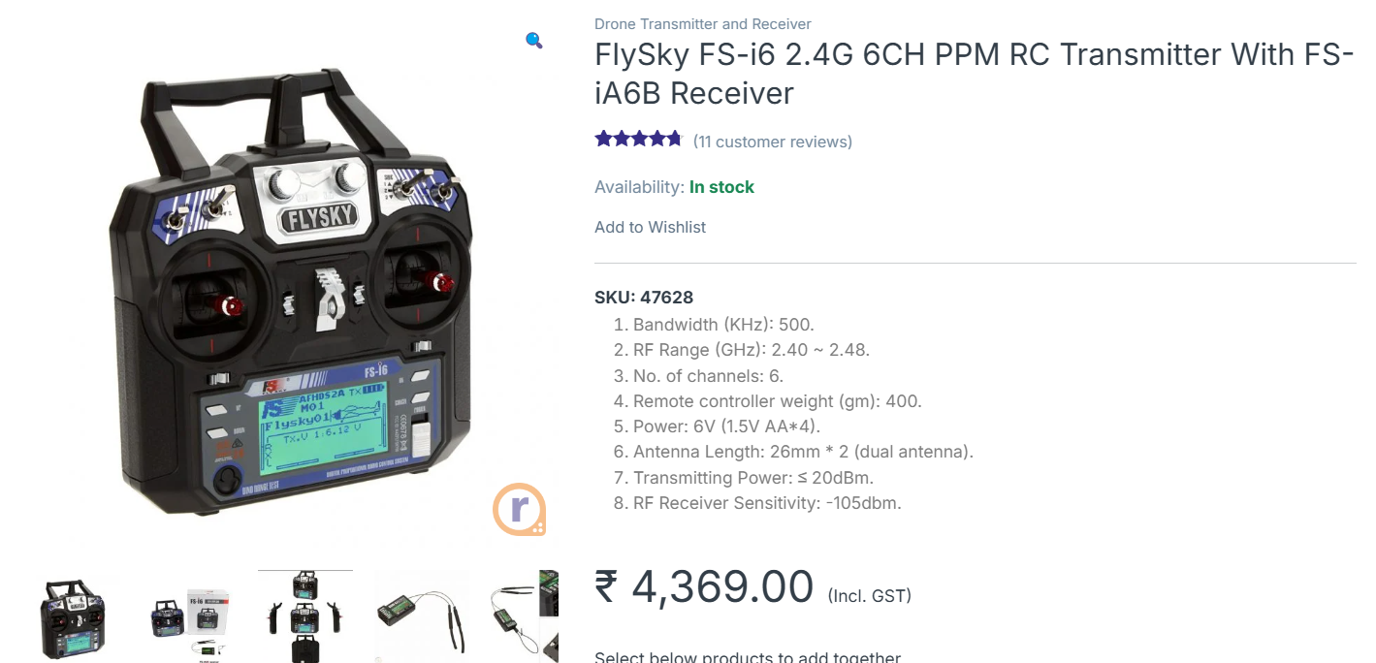

**11. CAMERA :**

1. 1/3″ CMOS 1500TVL Mini FPV Camera 2.1mm Lens PAL / NTSC With OSD

Link : https://robu.in/product/1-3-cmos-1500tvl-mini-fpv-camera-2-1mm-lens-pal-ntsc-with-osd/

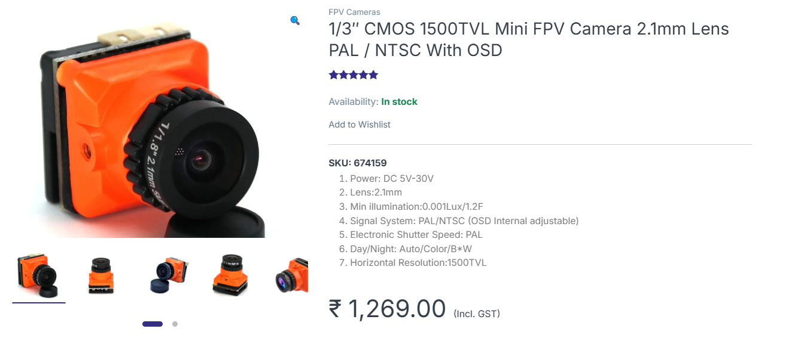

**2.** **5.8G UVC OTG Android AV Phone Receiver**

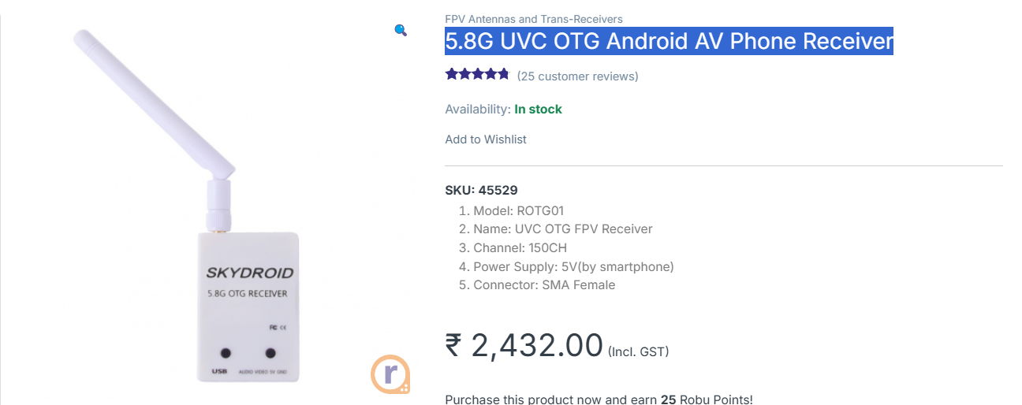

**3.** **EWRF TS5823 600mW Wireless Video Transmitter**

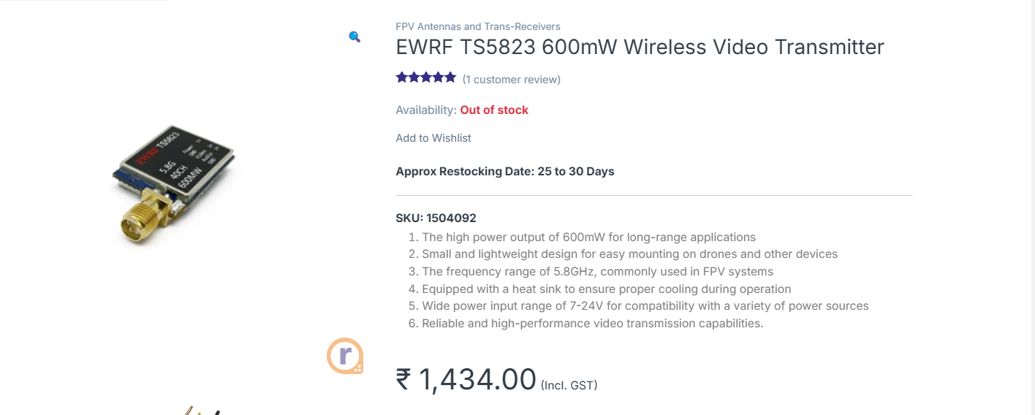

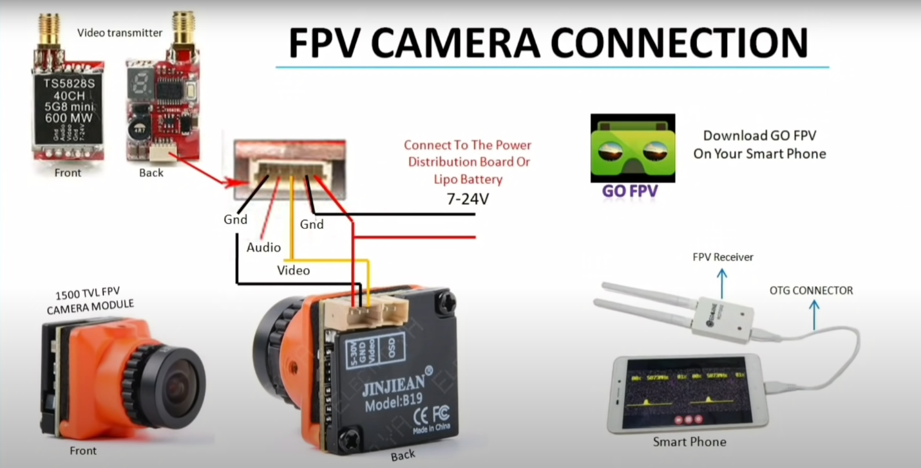

**Accessories/Tools:**

1.XT60 Male Connector With 9cm 14AWG Silicon Wire

2. 20cm Lipo Battery Strap Belt For Drone

3. 1× 150mm Self Locking Adjustable Nylon Cable Ties | Zip Ties (White) 12pcs

4. 1× Allen Key 2mm

5 .1× Allen Key 2.5mm

6. 1× High-Quality Ultra

Flexible 20AWG Silicone Wire 1m – Black

7.1× Heat Shrink Sleeve 2mm Black 1meter

8. 25W 230V Soldering Iron (Rajshri).

9.Solder Wire 27gm.

10.Wire Cutter/Stripper 150mm - Taparia.

**Video link :**

**https://youtu.be/_9ALoraoeCE?si=46ToM3oDF8TTvqrI**